What to Do Before a Tropical Storm or Hurricane

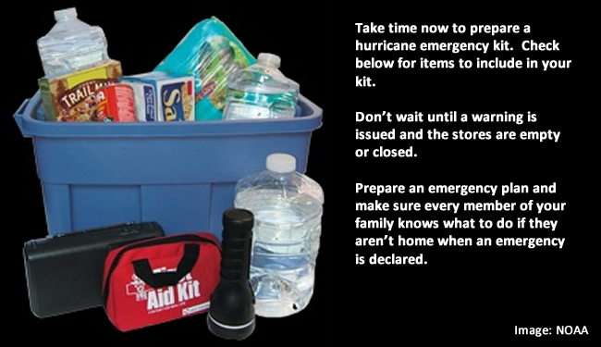
The best time to prepare for a hurricane is before hurricane season begins on June 1. It is vital to understand your home's vulnerability to storm surge, flooding, and wind.

Here is your checklist of things to do BEFORE hurricane seasons begins:

- Know your zone: Do you live near the Gulf or Atlantic Coasts? Find out if you live in a hurricane evacuation area by contacting your local government/emergency management office or by checking the evacuation site website.
- Put Together an Emergency Kit: Put together a basic emergency. Check emergency equipment, such as flashlights, generators and storm shutters.
- Write or review your Family Emergency Plan: Before an emergency happens, sit down with your family or close friends and decide how you will get in contact with each other, where you will go, and what you will do in an emergency. Keep a copy of this plan in your emergency supplies kit or another safe place where you can access it in the event of a disaster. Start at the Ready.Gov emergency plan webpage.
- Review Your Insurance Policies: Review your insurance policies to ensure that you have adequate coverage for your home and personal property.
- Understand NWS forecast products, especially the meaning of NWS watches and warnings.
- Preparation tips for your home from the Federal Alliance for Safe Homes
- Preparation Tips for those with Chronic Illnesses

Download our checklists and more free resources.
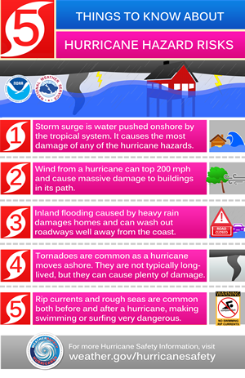
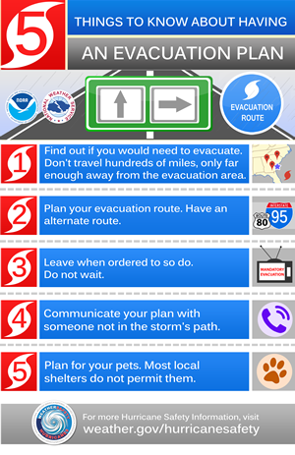
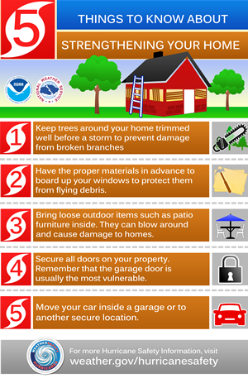
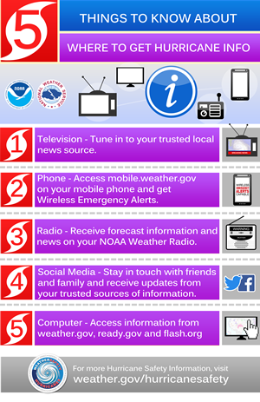

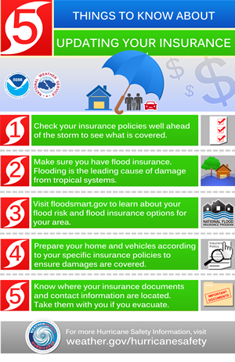
Source:
US Dept of Commerce
National Oceanic and Atmospheric Administration
National Weather Service
Safety
1325 East-West Hwy, 18th floor
Communications Office
Silver Spring, MD 20910

